TROY USD 429
WEEKLY ACTIVITIES SCHEDULE – Week 7
OCTOBER 9-14– Bus Duty 3
HAPPY NATIONAL ACTIVITIES WEEK!
Monday, October 9
TMS Football @ SPPS (Nemaha Central HS FB Field – 214 N 11th St., Seneca, KS)/54 min.
Bus Departs @ 5 PM
Board of Education Meeting – 5 PM; Troy Central Office
Tuesday, October 10
THS Volleyball Quad @ Wash Co w/Frankfort & CC – JV @ 5 pm/ Varsity @ 6 PM
Bus Departs @ 1:30 PM/Driver -?/115 N D St., Washington, KS
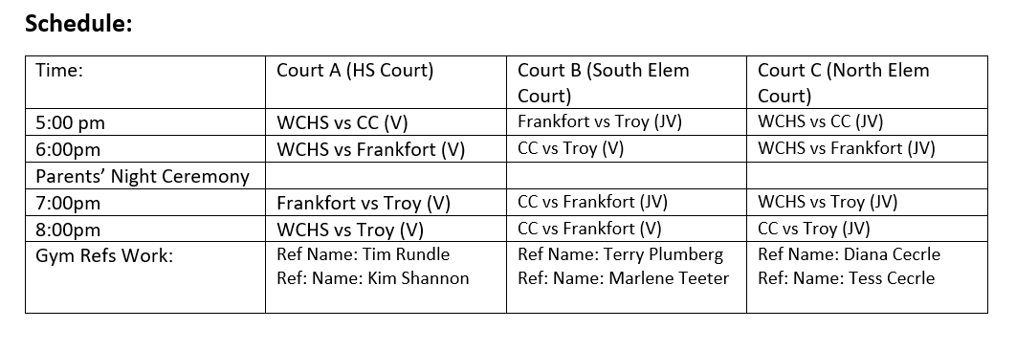
Wednesday, October 11
FFA Dairy Judging – Bus Departs @ 8 AM @ Sabetha
Thursday, October 12
TVL Cross Country hosted by Axtell @ Spring Creek Gold Course, 1800 Spring Creek Dr., Seneca, KS
Bus Departs @ 1:50 PM/ Driver – Roger Purdy
THS Volleyball Quad @ Horton (Varsity Only) – 5 PM/1120 Frist Ave E, Horton KS
Bus Departs @ 3:15 PM / Driver -
Friday, October 13
THS FB @ Troy vs Onaga- 7 PM
Senior Night @ 6:30 PM
FFA Pumpkin Decorating Voag Shop – 6:30 PM
Saturday, October 14
TVL Volleyball @ Washington County – 8 AM
Bus Departs @ 5:30 AM/Driver -?/115 N D St., Washington, KS

